PERSONAL INFORMATION

Kính gửi: Công ty TNHH Framgia Việt Nam
Full name: Đình Văn Thắng
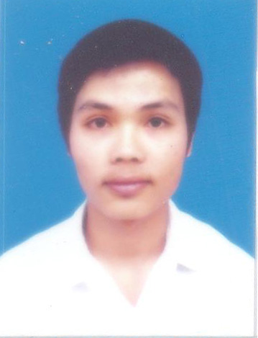
Date of birth : 22/04/1990
Address: Hải Bối,Đông Anh,Hà Nội
Phone: 0979 056 938
Email: tvd.nuce@gmail.com
Possition applied for:
Developer PHP.
EDUCATION:

University : National University Of Civil Engineering

Department : Information technology.

Graduation year : 2013.

EXPERIENCES:
-Code website for sale mobile phone used CMS joomla.
-Code PHP at NoVa Ads since 22/09/2012 to 28/02/2013
-Code C/C++ at FPT software since 12/10/2012 to 29/03/2013.
-Code PHP at HGTECH jsc since 04/06/2013.
SKILLS:
-Search document
-English
-Microsoft office

